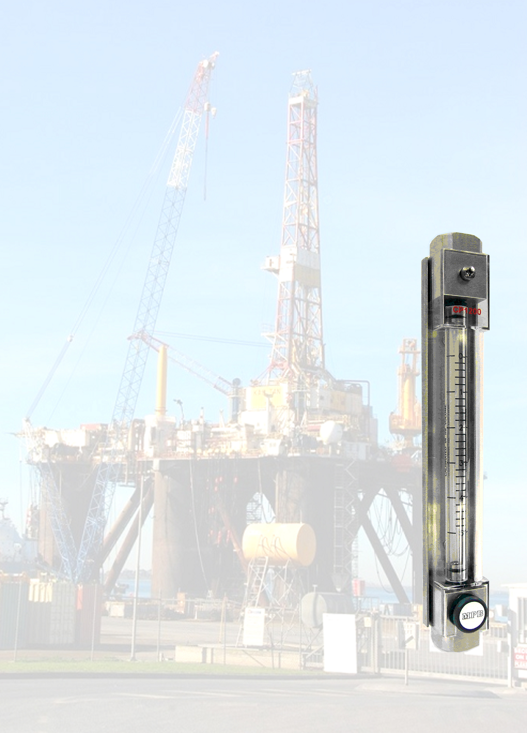

**MPB SERIES CP1200 FEATURES**

* VERY LOW CALIBRATION SCALES TO 2cc
* WIDE RANGE OF STANDARD CAPACITIES FROM 2cc to 20cc

(SEE FULL RANGE OVERLEAF)

* EASY TO READ
* CALIBRATED SCALES WITH TRACEABLE CERTIFICATES
* SPECIAL SCALES ‘DOWN READ’ TO CUSTOMERS

SPECIFICATION IF REQUIRED

* THREADED, OR FLANGED CONNECTIONS
* PRECISION BORE BOROSILICATE GLASS CYLINDERS
* POLYCARBONATE COVERS AS STANDARD
* PERMANENTLY FIRED SCALES WITH WHITE

BACKING TO GIVE EXCELLENT CLARITY

* PUMP SETTING GAUGE
* PUMP RATE CHECKING
* CALIBRATION TUBE EASILY REMOVED IN SITU FOR CLEANING
* FOR CAPACITIES FROM 50ml to 250ml SEE MPBTB 031 (CP100)
* FOR CAPACITIES FROM 500cc to 10,000ml SEE MPBTB 077 (CP110)

**GENERAL INFORMATION**

This range of precision calibration cylinders have been designed to meet the requirements of high accuracy and robust construction where metering low capacity outputs is essential.

This product range is usually supplied with threaded connections; however, flanges can be

supplied if specified.

Ideal for use as a low flow pump setting gauge, or pump rate checking.

Materials of construction include 316 Stainless steel, super duplex Stainless steel, titanium, Hastelloy, rigid PVC and polypropylene. These are typical of the specifications MPB can provide.

**MPB SERIES CP1200 CALIBRATION CYLINDER**

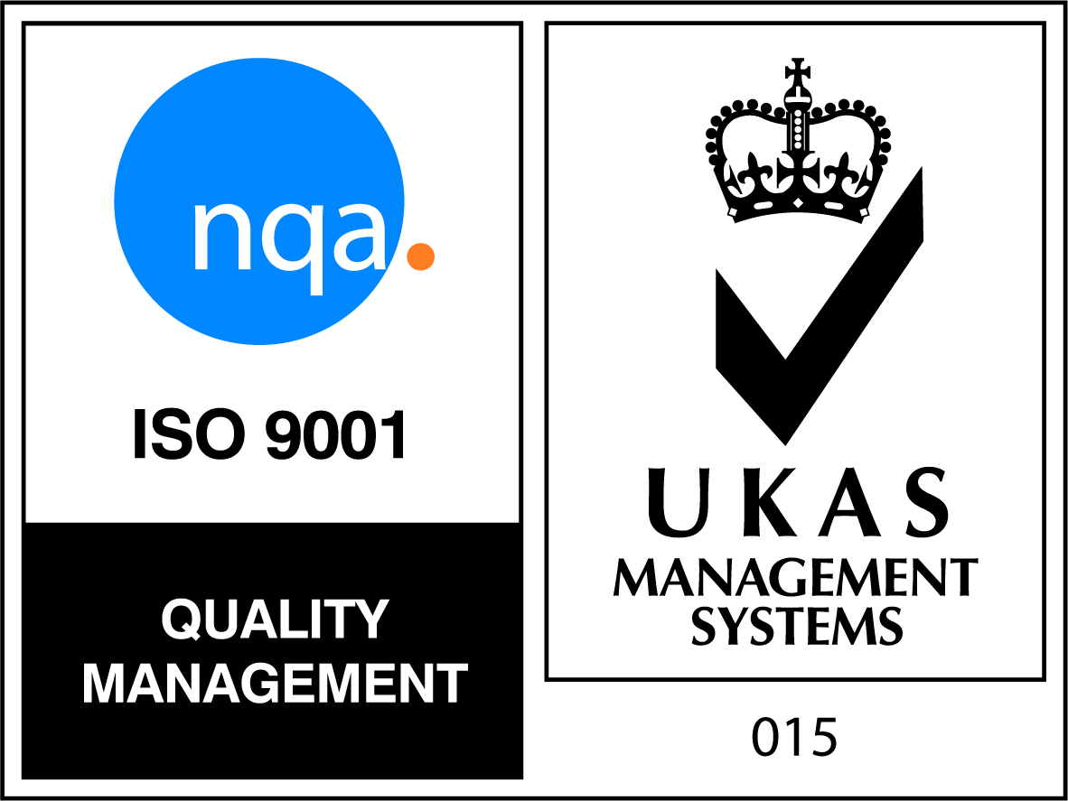

**Product Data Sheet**

cid:image003.png@01D510B9.96411720

**100mm**

**100mm**

**100mm**

**100mm**

**100mm**

**100mm**

**100mm**

**MPVA 807**

**MPVA 807**

**MPVA 807**

**MPVA 807**

**MPVA 807**

**MPVA 807**

**MPVA 807**

**DRAWING NUMBER**

**End Connections:**

**316 Stainless steel, Super Duplex**

**Stainless steel, Titanium, Hastelloy,**

**Rigid PVC and Polypropylene**

**Threaded, or flanged to customer**

**requirements.**

**Fully certified where requested.**

**Seals: Viton, Nitrile, EPDM, etc**

**Cylinder: Fully stress relieved precision bore**

**Borosilicate glass**

**Scale: Permanently fired black ceramic**

**Maximum Working Pressure: 13.3 Barg**

**Maximum Working Temperature:**

**60°C RPVC**

**100°C Stainless steel**

**Accuracy: ± 2% of actual reading**

**SCALE LENGTH**

**¼” NPT**

**¼” NPT**

**¼” NPT**

**¼” NPT**

**¼” NPT**

**¼” NPT**

**¼” NPT**

**20ml**

**15ml**

**10ml**

**7.5ml**

**5ml**

**3ml**

**2ml**

**CAPACITY**

Alternative capacities and connections are available,

please contact MPB Sales Office

with precise requirements

**CONNECTION**

*MPB Industries Ltd - Designers and Manufacturers of Scientific and Process Control Instrumentation*

Part of the Scientific Digital Imaging plc (SDI) group of companies

Unit 1 Branbridges Ind Est, East Peckham, Kent TN12 5HF, UK, Tel: +44 (0)1622 872401

[mail@mpbflowmeters.com](mailto:mail@mpbflowmeters.com), www.mpbflowmeters.com

**For additional information on the Sight Level Indicator or any of our flowmeter products,**

**please call our Sales Office on (01622) 872401.**

**MPB SERIES CP1200 CALIBRATION CYLINDER**

Due to the constant development and improvement of products, information may be altered or withdrawn without notice.